Ideation Phase
Brainstorm & Idea Prioritization Template

Date | 31 January 2025
Team ID | LTVIP2026TMIDS41887
Project Name | visualization tool for electric vehicle charge and range analysis
Maximum Marks | 4 Marks

Brainstorm & Idea Prioritization Template:
A multidisciplinary team with expertise in EV data analysis, visualization, and web technologies was formed to explore EV charging and range analysis challenges. Brainstorming sessions identified key issues such as scattered EV datasets and lack of unified visualization platforms, leading to the idea of an integrated EV analytics tool. The problem statement is “How might we create an interactive visualization platform that integrates multiple EV datasets to analyze charging behavior and driving range trends?”.
Step-1: Team Gathering, Collaboration and Select the Problem Statement
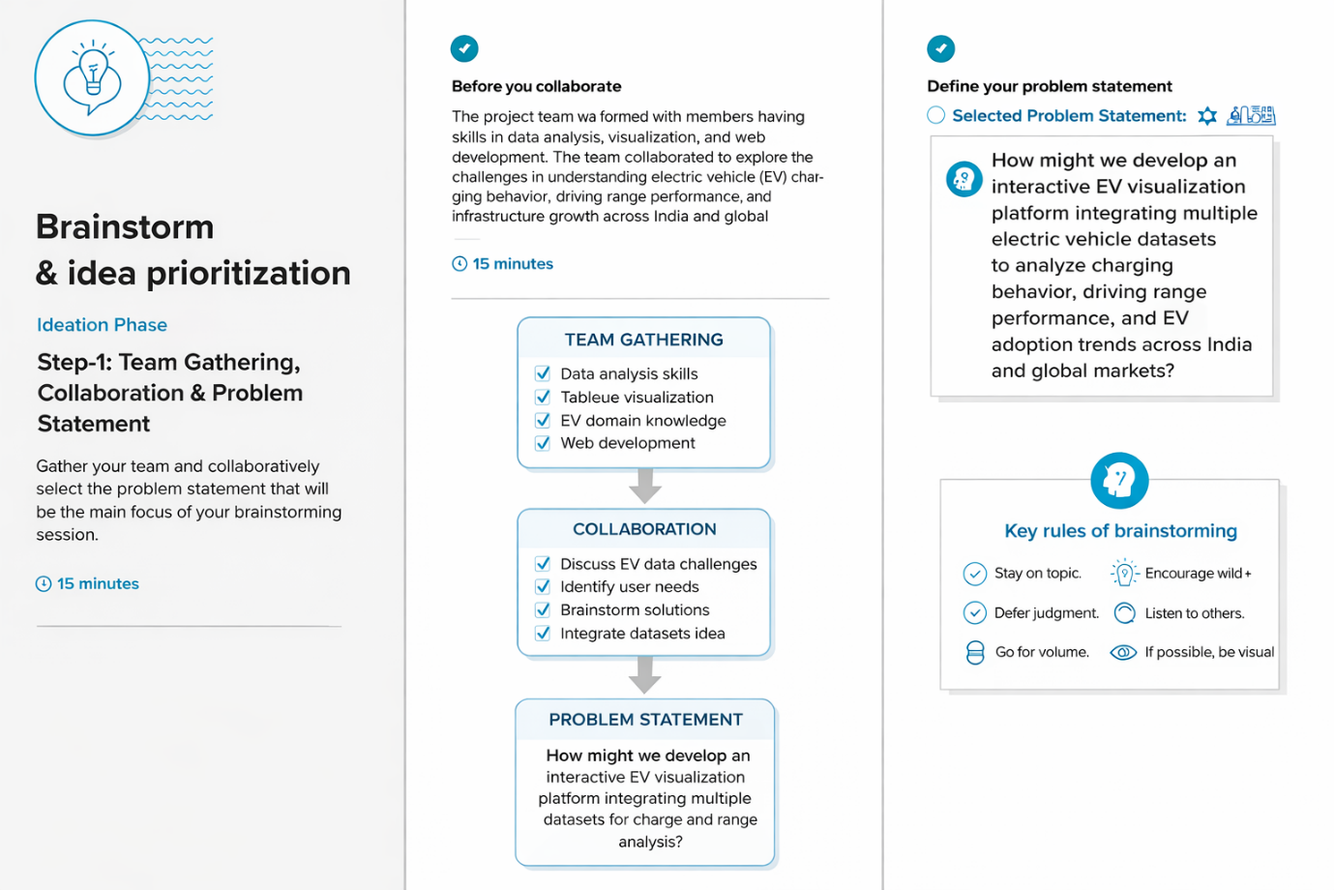

Step-2: Brainstorm, Idea Listing and Grouping
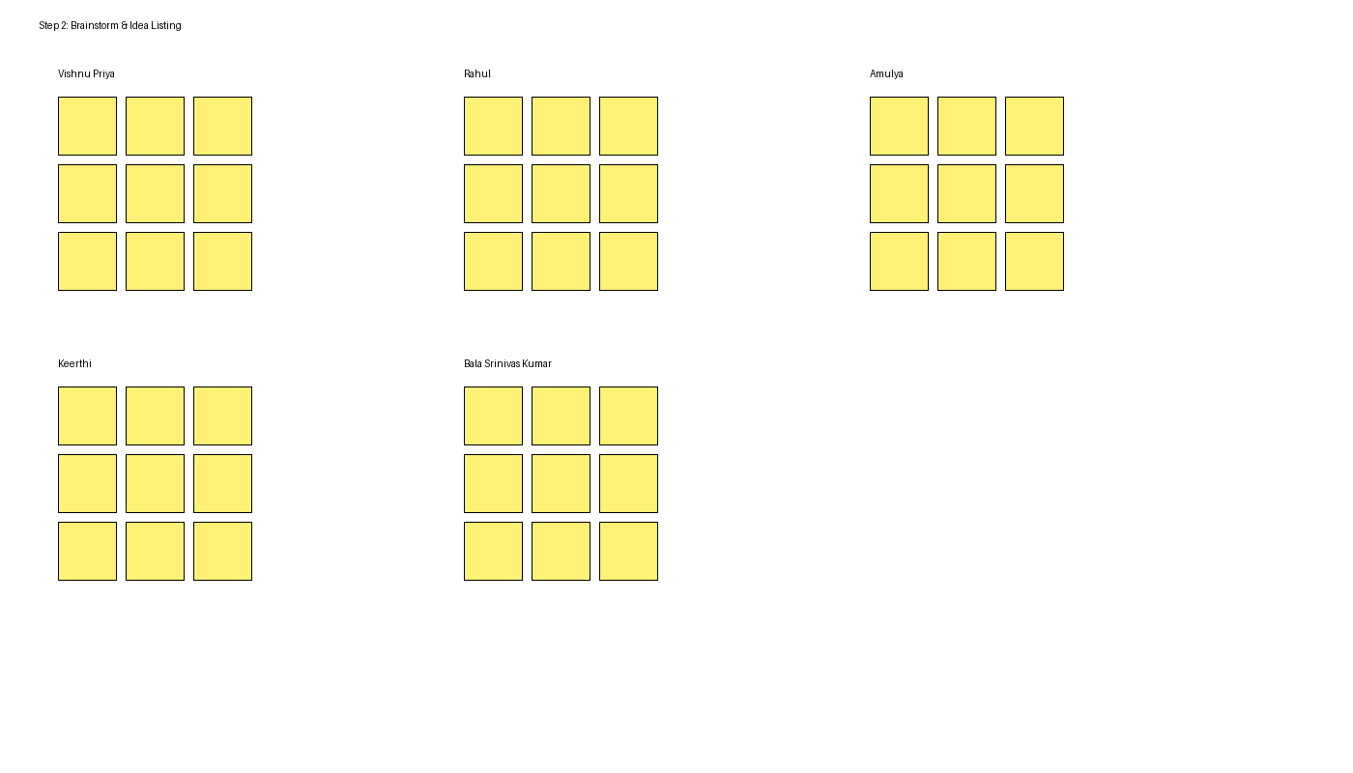

Step-3: Idea Prioritization
